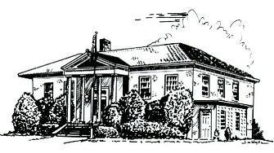

PERRY PUBLIC LIBRARY

70 N. Main Street Make It Part of Your Day
Perry, New York 14530

PHONE (585) 237-2243 FAX (585) 237-2008 WEBSITE perry.owwl.org

Library Board Meeting Agenda
August 3, 2020
1.) | Pledge to Flag
2.) | Consideration of Agenda and Conflict of interest | DISCUSS
3.) | Approval of July 6, 2020 minutes | VOTE
4.) | Account Payable Voucher | VOTE
5.) | YTD Budget | REVIEW AND DISCUSS
6.) | Capital Fund  1.) Account Payable Voucher  2.) YTD Budget | 1.) VOTE  2.) DISCUSS
7.) | Staff Reports  1.) Director’s | DISCUSS
8.) | Committee Reports  1.) Development Committee - Long Range Plan Draft  2.) Building Committee – Project Update | DISCUSS
9.) | New Business | DICUSS
10.) | Old Business | DISCUSS
11.) | Adjourn | VOTE
Dates | September Board Meeting – September 14, 2020 7:00PM  October Board Meeting – October 5, 2020 7:00PM

