Animal Tales Extension Activity Sheet
Thank you for checking out our kit! The following suggestions are provided to assist you in your family’s exploration of animals based on our theme of Tales and Tails. We hope you use these resources to continue habits of learning, curiosity, and reading.

Recommended Additional Titles
See also our curated list for related titles, available at: www.perry.owwl.org or by stopping into the library.
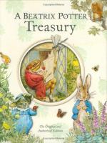
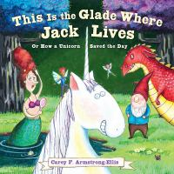
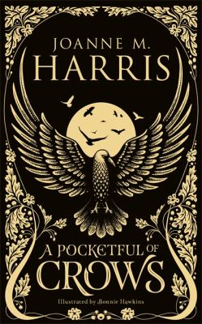
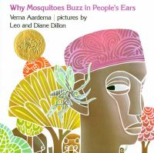
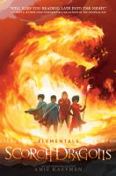

Scorch Dragons by Amie Kaufman
Why Mosquitos Buzz in People’s Ears by Verna Aadema
A Pocketful of Crows by Joanne M Harris
This is the Glade Where Jack Lives by Carey Armstrong Ellis
A Beatrix Potter Treasury by Beatrix Potter

Recommended Online Resources
These links and videos have been reviewed before selection, but please consider reviewing them before allowing your child to view them.

https://www.storynory.com/category/fairy-tales/animal-stories/
Animal Tales both audio and text.

https://fairytalez.com/
More Fairy Tales from around the world, many with audio and text.

https://edsitement.neh.gov/lesson-plans/helpful-animals-and-compassionate-humans-folklore
Lesson plan with helpful questions & charts for a deep dive into the why behind tales.
https://www.dltk-kids.com/storyteller/index.htm
One of our favorite websites for children’s activities
also has a storytelling video series!

Paper Roll Mermaid
Inspired by Laura Dubiel via Pinterest
Materials:

Paper Roll
Tissue Paper
Pipe Cleaner
Yarn
Shells
Tape
Glue
Scissors
Markers
Decorations (sequins, glitter, etc.)

- If using a paper towel roll, cut in half. Cut a piece of tissue paper to fit around the roll twice. Wrap the tube, and pull the tissue paper down so that the top half is exposed for the face and shells.
- Tape the tissue paper to the roll so that it stays wrapped and then twist the bottom portion so that it stays wrapped. Cut a tail shape below the twist.
- Above the tail, draw a face and glue the shells on for a shirt.
- Figure out how long you want the hair, double it and layer as you like to create the volume. Glue to the top of the tube.
- Decorate the hair and tail as you like with your extra supplies.
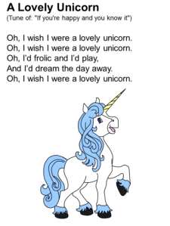
Three Little Pigs Spoons
https://masandpas.com/three-little-pigs-story-spoons/
Materials
https://www.dltk-teach.com/alphabuddies/songs/u/lovelyunicorn.htm

4 Wooden Spoons
Acrylic Paint
Paintbrushes
Permanent Marker
Optional: Yarn or Ribbon

- Make sure the spoons are clean and dry. Paint the spoons- 3 pink and 1 grey or brown. You may need 2 coats. Let dry.
- Using either markers or paint, add details to the spoons to create your characters’ faces.
- Add yarn or ribbon to help differentiate the characters.
- Use these spoons to retell the Three Little Pigs and also tell other stories.
- Explore other stories you can use spoons to help tell!

