Animals (and People) at Work Extension Activity Sheet
Thank you for checking out our kit! The following suggestions are provided to assist you in your family’s exploration of animals based on our theme of Tales and Tails. We hope you use these resources to continue habits of learning, curiosity, and reading.

Recommended Additional Titles
See also our curated list for related titles, available at: www.perry.owwl.org or by stopping into the library.
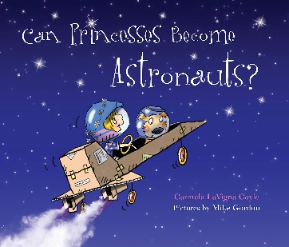
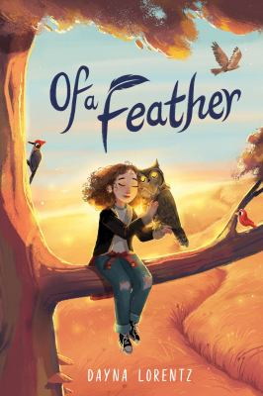
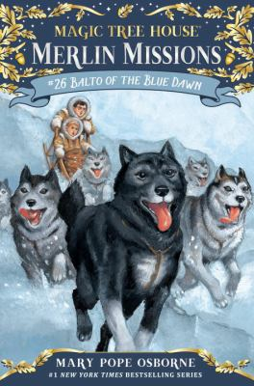
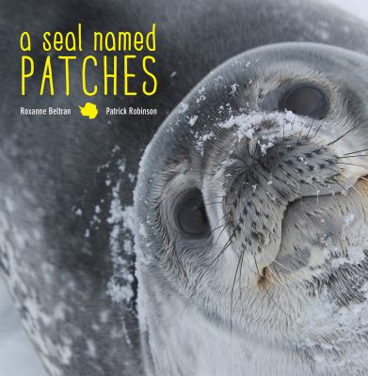
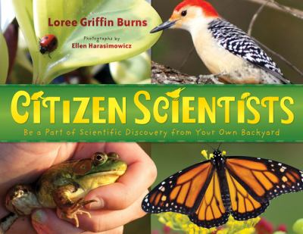

Can Princesses be Astronauts by Carmela LaVigna Coyle
Of a Feather by Dayna Lorentz
A Seal Named Patches by Raxanne Beltran
Magic Tree House: Balto of the Blue Dawn by Mary Pope Osborne
Citizen Scientists by Loree Griffin Burn

Recommended Online Resources
These links and videos have been reviewed before selection, but please consider reviewing them before allowing your child to view them.
https://www.youtube.com/watch?v=z3Ng_L2QYJ4
HiHo Kids meet a Vet

https://www.youtube.com/playlist?list=PLQlnTldJs0ZTswqn44CKo8prG5ph-yTHd
National Geographic for Kids series on Veterinarians

https://www.britannica.com/list/working-like-a-dog-7-animals-with-jobs
Talks about jobs that animals have

https://vcahospitals.com/know-your-pet/therapy-pets
Information on therapy pets

https://www.youtube.com/watch?v=IjXeZpNT558
Interview with a wildlife educator

AT THE VETERINARIAN’S
Tune: “Down By The Station”
At the veterinarian’s
Early in the morning,
See the little puppies
Waiting in a row.
See the veterinarian
Give the puppies checkups.
Arf! Arf! Arf!
Now, home they go.
by Heather McPhail
Continue with verses about other animals and their sounds or actions:
“Kitties – Mew, mew, mew; Turtles – Crawl, crawl, crawl” and so on.

Veterinarian Dramatic Play
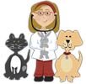
Sources: http://alongingfulfilled.blogspot.com/2012/09/
veterinarian-birthday.html?m=1
https://www.momsandmunchkins.ca/free-vet-printables/
https://suburbanwifecitylife.com/diy-toy-stethoscopes/

Help your kids pretend they are veterinarians by putting together a Vet Kit including bandages, gloves, craft sticks, etc. If you have a clean medicine dose plunger or stethoscope, add those too. Set up a vet clinic for your stuffed animals and print out from the sources above, or create a patient chart including name, owner, type of animal, color, height, length, symptoms, treatments, etc.
Dog Sled Model Inspired by https://teachinginthemuseum.wordpress.com/

Paper
Base: Cardstock/ Cereal box
Popsicle sticks
Glue
Markers or crayons
Yarn or string
Tape
Optional: Sled Dog Clipart

- Start building the frame for your dog sled. At one end your base, measure using one craft stick long edge against the edge and mark each end. Glue two craft sticks to the base on their sides just inside the marks you made. Let dry.
- Find pictures of sled dogs. If you are able to, print out sled dog clipart or draw sled dogs on paper. Fold the paper in half so the fold meets the top of your dog’s head. Cut out around the dog, making sure to leave the fold as well as extra paper at the bottom. Fold the extra paper up so that it overlaps and tape together. You may also need to tape at the top where the dog’s back is. Repeat for all the dogs you would like.
- If your sled runners are dry, glue on 4 craft sticks spaced evenly as cross pieces. They should fit across the runners with a little overhang.
- On the end of the sled nearest the edge of the base, glue two sticks to the runners so that they are angled to look like a handle. You might need something to support them so they stay at the angle you want. Let dry.
- Place your dogs in front of your sled. You can glue or tape them down once they are arranged as you like. Using the yarn, connect the dogs together.
- After the angled pieces of the sled have dried, glue one more cross piece at the top of the handle and then glue the yarn to that top cross piece.

