Animals of the Sand and Sea Extension Activity Sheet
Thank you for checking out our kit! The following suggestions are provided to assist you in your family’s exploration of animals based on our theme of Tales and Tails. We hope you use these resources to continue habits of learning, curiosity, and reading.

Recommended Additional Titles
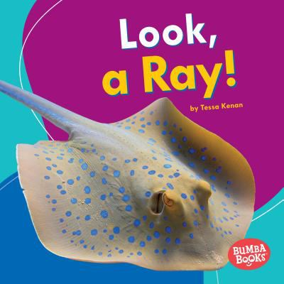
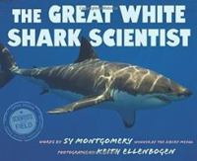
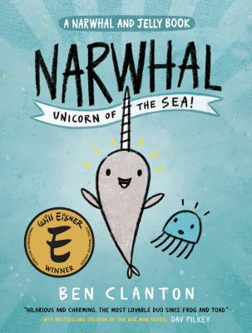
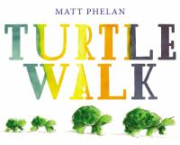
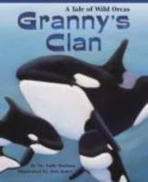
See also our curated list for related titles, available at: www.perry.owwl.org or by stopping into the library.

The Great White Shark Scientist by Sy Montgomery
Look, a Ray! by Tessa Kenan
Narwhal: The Unicorn of the Sea by Ben Clanton
Turtle Walk by Matt Phelan
Granny’s Clan: A Tale of Wild Orcas by Sally Hodson

Recommended Online Resources
These links and videos have been reviewed before selection, but please consider reviewing them before allowing your child to view them.

https://www.youtube.com/watch?v=diff-rQe57Q
Estuary Science Experiment from the NYS Dept of Environmental Conservation

https://explorebeaches.msi.ucsb.edu/sandy-beach-life
Animals you might find while at the beach

https://oceana.org/marine-life
Encyclopedia of Ocean Animals

https://www.youtube.com/playlist?list=PLQlnTldJs0ZTLL3_CbqRfzyBeXQOQrw2d
Playlist of Amazing Animals-Ocean Animals by National Geographic for Kids

https://www.youtube.com/watch?v=UuskKfv2zxI
https://www.youtube.com/watch?v=ulIQ9_BB8KA
Victor Vescovo discusses Deep Ocean diving and his record-breaking dive to the deepest part of the ocean

Handprint Walrus Craft
(https://www.simpleeverydaymom.com/handprint-walrus-craft-for-kids/)

Paper (white, brown & black)
Black marker
Scissors
Glue
Pencil
Optional: Template from website

- Cut out all the pieces. If not using a pattern, draw the shapes lightly with a pencil.
- The walrus body is a medium brown, shaped like rounded triangle where the bottom is slightly shorter than the two equal side.
- A lighter shade of brown can be used to cut out an oval that covers the bottom of the body and glue down.
- Cut out two white tusks, shaped like a long thin banana cut in half. Cut out one heart shape from the same color as the belly for the muzzle. Arrange the tusks so that half the tooth hangs over the belly. Then, place the heart over the tusks. They should be about halfway up the body. The heart is upside down and the point is pointing toward the middle of where the eyes will go.
- Use a small oval of black for the nose. Glue on top of the point of the heart.
- Two white circles can be the eyes. Glue these above the nose.
- Trace around both child’s hands in the same brown as the body. Cut out and paste on as flippers, with the palms on the belly.
- Decorate with the black marker: eyes, dots for the whiskers on the nose.
I’m a Little Fish
(Tune of I’m a Little Teapot)
Bubble Wrap Turtle (Inspired by
https://www.gluedtomycraftsblog.com/)
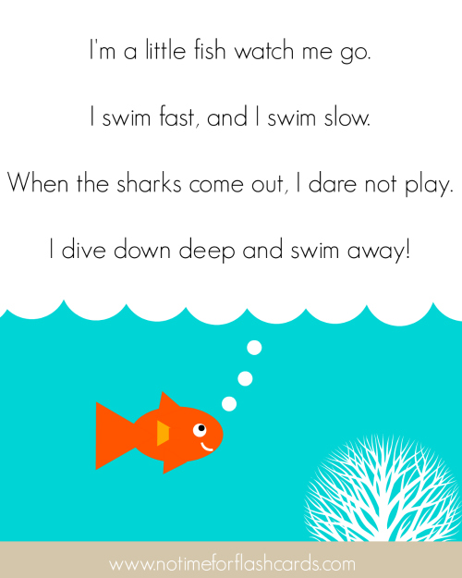
Materials

Paper (white, green)
Glue
Scissors
Bubble wrap
Brown paint
Googly Eyes

- Cut out an oval from white paper and bubble wrap. Glue the two together, with the bubble side facing out or away from the paper. Paint bubble wrap brown.
https://www.notimeforflashcards.com/2016/06/little-fish-song-for-preschool.html

- Using green paper, or color white paper green, cut out a circle for the head, two long football shapes for the front flippers, two banana shapes for the back flippers, and a small circle for the tail.
- After your turtle shell is dry, glue the head, fins, and tail to the back side of the shell.
- Add googly eyes, and other details you’d like.

