Extension Activity Sheet
Thank you for checking out our kit! The following suggestions are provided to assist you in your family’s exploration of animals based on our theme of Tales and Tails. We hope you use these resources to continue habits of learning, curiosity, and reading.

Recommended Additional Titles
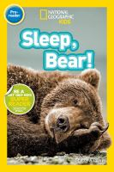
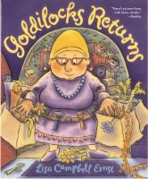
See also our curated list for related titles, available at: www.perry.owwl.org or by stopping into the library.
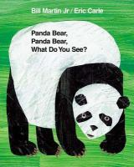
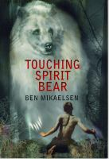
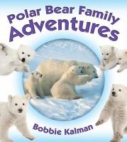
Sleep, Bear! by Shelby Alinsky
Goldilocks Returns by Lisa Campbell Ernst
Polar Bear Family Adventures by Bonnie Kalman
Touching Spirit Bear by Ben Mikaelsen
Panda Bear, Panda Bear, What Do You See? By Bill Martin & Eric Carle

Recommended Online Resources
These links and videos have been reviewed before selection, but please consider reviewing them before allowing your child to view them.

https://bear.org/bear-facts/black-bears/basic-bear-facts/
Facts and discussion about black bears, brown or grizzly bears, and polar bears.

https://kids.sandiegozoowildlifealliance.org/animals/andean-bear
https://kids.sandiegozoowildlifealliance.org/animals/brown-bear
https://kids.sandiegozoowildlifealliance.org/animals/polar-bear
https://kids.sandiegozoowildlifealliance.org/animals/sloth-bear
https://kids.sandiegozoowildlifealliance.org/animals/giant-panda
San Diego Zoo links all about bears!

https://www.youtube.com/watch?v=U8xvlmdWtMs&t=12s https://www.youtube.com/watch?v=XdCaBF8NJ00
https://www.youtube.com/watch?v=rJI6qIyA0WM
National Geographic for Kids featuring Bears!

https://www.youtube.com/watch?v=qdSVMkqVCos&t=30s
Latest update from the Buffalo Zoo about Luna, their polar bear

Fork Painted Bear

Paint- black, brown or white
Paper
Markers or crayons
Fork
Scissors
Glue
Optional: Googly eyes

- Decide which kind of bear you want to paint! White for a polar bear, black for black bears, brown for grizzly bears.
- Paint your bear with a fork. Generally, the end shape should be round for the bear’s face but you could also make the whole bear using this technique. It might be helpful to trace an outline so that you know where the painting should end. Let dry completely.
- Trace face details (ears, nose, mouth) for your bear and cut out. Color will vary depending on which bear you decide to make!
- Glue on your face details. Add your optional googly eyes or cut eyes from paper.

Teddy Bear Picnic or Tea Party
Pack a picnic to take to the park or in your yard. You could also do this as a tea party inside! Luckily, bears are omnivores (eat both plants and meat), so that should make it easy to pack a lunch. They eat berries and fruit, tubers like potatoes or yams as well as others, mushrooms, and any kind of meat they can find.

Make sure to bring your teddy bears (or other stuffed animals) and serve them as well. This is a perfect time to share memories about stuffed animals you had as a child or stories about where the stuffed animals attending the tea came to live with your family.

Bear information from https://www.fws.gov/mountain-prairie/es/grizzlyBearHistoryHabitatDiet.php

Five Little Bears
(Follow the motions either with your whole body or using your finger!)

Five little bears were dancing on the floor
One fell down and that left four.
Four little bears climbed up a tree
One found a bee hive and that left three.
Three little bears were wondering what to do
One chased a bunny rabbit that left two.
Two little bears were looking for some fun
One took a swim that left one.
One little bear sitting all alone
He looked all around and then ran home.

Dance around
Fall down
Pretend to climb
Pretend to eat honey (bears love it!)
Shrug your shoulders
Pretend to run after a rabbit
Put hand over eyes and look around
Pretend to swim
Sit down and look sad
Look around and slowly run away

