Barnyard Animals Extension Activity Sheet
Thank you for checking out our kit! The following suggestions are provided to assist you in your family’s exploration of animals based on our theme of Tales and Tails. We hope you use these resources to continue habits of learning, curiosity, and reading.

Recommended Additional Titles
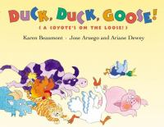
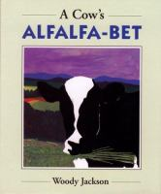
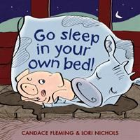
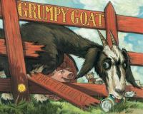
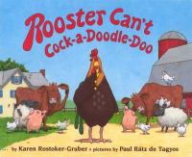
See also our curated list for related titles, available at: www.perry.owwl.org or by stopping into the library.

A Cow’s Alfalfa=bet by Woody Jackson
Go Sleep in Your Own Bed! by Candace Fleming & Lori Nichols
Grumpy Goat by Brett Helquist
Rooster Can’t Cock-a-Doodle-Doo by Karen Rostoker-Gruber
Duck, Duck, Goose! By Karen Beaumont

Recommended Online Resources
These links and videos have been reviewed before selection, but please consider reviewing them before allowing your child to view them.

https://www.youtube.com/watch?v=1pIPX81mqIo
Mrs. Guy’s Farm Field Trip with Animal Facts

https://www.youtube.com/watch?v=oD2hx0uyhMo
Hand-milking Cows (and goats!)

https://www.youtube.com/watch?v=hAWVXG-e2pI
Milking Cows with automatic milkers

https://ny.pbslearningmedia.org/resource/evscps.sci.life.getfrom/what-do-you-get-from-that/
What Do You Get From That? Farm Edition, PBS

Spinning Chicken Craft https://booksandgiggles.com/barnyard-dance-craft-chicken/
Materials:

White paper (construction or cardstock) or paper plate
Markers or Crayons
Scissors
Glue
Tape
Pencil
Optional: Orange Paper
Optional: Red paint
Optional: Googly Eyes

- Paint 3 fingers and stamp onto white paper. You could also trace around the child’s fingers and color in red.
- Trace around a small plate and cut out paper or cut off the rim of a paper plate.
- Cut out or draw a triangle for the beak.
- Glue on googly eyes or draw on eyes.
- Cut out red fingers for comb on top of chicken’s head and glue on.
- Tape a pencil or cylinder object to the back of the chicken.
- Your chicken is ready! Place the pencil between your palms and roll back and forth.
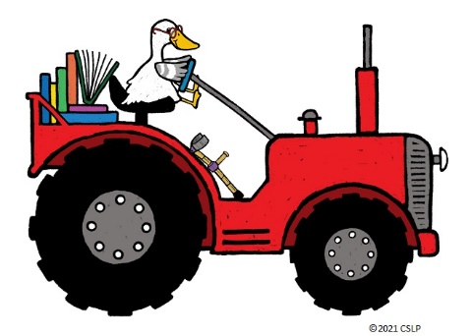
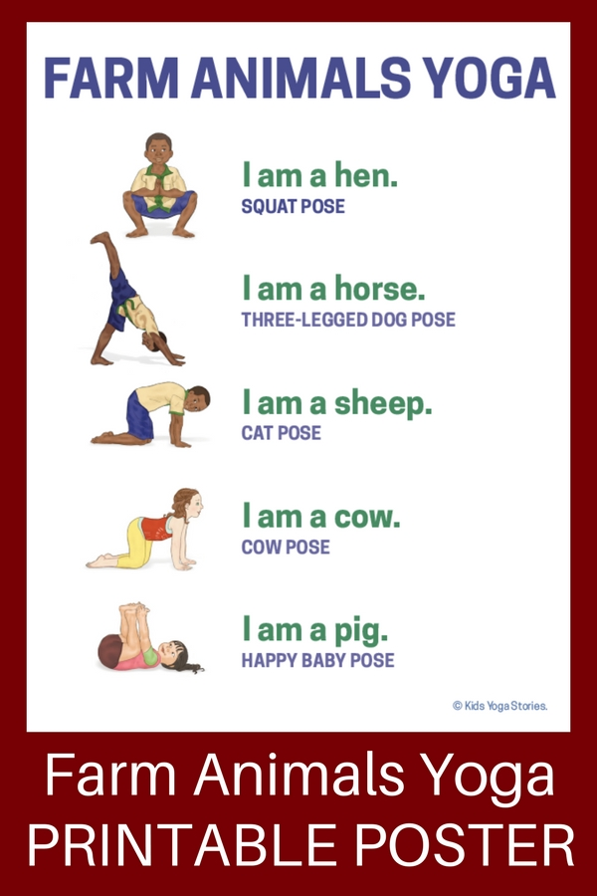

Song: To The Farm
(Tune of Twinkle, Twinkle Little Star)
Author Unknown
https://www.kidsyogastories.com/farm-animals-yoga/
Chickens, kittens, piglets too,
Donkeys, horses, cows that moo.
Fish that swim down in the pond,
Ducklings quacking all day long.
All these things you can see
If you go to the farm with me.

