Birds of a Feather Extension Activity Sheet
Thank you for checking out our kit! The following suggestions are provided to assist you in your family’s exploration of animals based on our theme of Tales and Tails. We hope you use these resources to continue habits of learning, curiosity, and reading.

Recommended Additional Titles
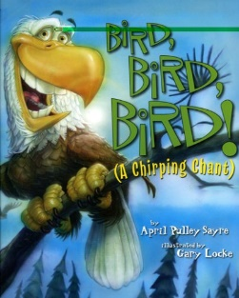
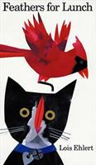
See also our curated list for related titles, available at: www.perry.owwl.org or by stopping into the library.
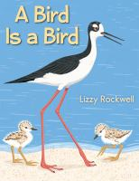
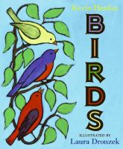
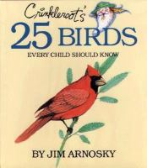
Crinkleroot’s 25 Birds Every Child Should Know by Jim Arnosky
Birds by Kevin Henkes
Feathers for Lunch by Lois Ehlert
A Bird is a Bird by Lizzy Rockwell
Bird Bird Bird! A Chirping Chant by April Pulley Sayre

Recommended Online Resources
These links and videos have been reviewed before selection, but please consider reviewing them before allowing your child to view them.
https://www.allaboutbirds.org/news/ The Cornell Lab
https://www.audubon.org/bird-guide The National Audubon Society
https://kids.nationalgeographic.com/animals/birds National Geographic for Kids
https://www.eagles.org/what-we-do/educate/live-hd-nest-cams/ Live Eagle Nest Stream

Bald Eagle Craft
Just Like an Owl
(to the tune of “London Bridge”)

Flap your wings and fly around,
fly around, fly around.
Flap your wings and fly around.
Just like an owl.
Other Verses:
Open your eyes big and wide…
Land on the ground and hop along
Turn your head and say “hoo hoo!”

http://www.literaryhoots.com/2015/02/owls-storytime.html

Inspired by https://www.craftingjeannie.com/eagle-craft-for-group-of-kids/

Colored paper- brown, white, yellow
Glue
Scissors
Markers
Optional: Template from website
Optional: Red & Blue paper
- Remember, if you don’t have colored paper you can use white paper and color what you need.
- From the brown paper, draw and cut out an oval for the body. Trace and cut out 2 hands for the wings.
- From the white paper, draw an egg shape then cut it in half. One half is for the head and one half is for the tail. Cut the tail half to resemble feathers.
- Starting with the wings and the tail, glue down to the base paper. Then glue the body on top and add the head. Cut a beak from the yellow paper and glue to face. Add face details.
- Optional: cut out stars from red, white, and blue to glue to or around the eagle.

Bird Cage Sculpture
From http://art-paper-scissors.blogspot.com/2012/04/bird-cage-sculptures.html
Tracers: https://www.template.net/design-templates/print/printable-bird-template/

Tagboard or cereal box
Paper
Colored pencils or markers
Yarn
Hole punch
Metal fastener
Glue
Scissors
Decorations for bird cage
Optional: Bird tracers

- Design and draw your bird outline on regular paper, using the tracer or by looking at pictures from birds. Make a mirror copy so you can cover the cardboard. Color both and cut out.
- Mark and punch a hole in each bird outline and on the cardboard.
- Glue one outline onto the cardboard and cut out. Glue the other onto the back. Make sure to line up the holes. Set aside
- Cut a wide strip from the cardboard and glue to make a ring for the base of the cage. Cut four long thin strips to form the arch. The arch should be about twice as tall as your bird.
- Glue one end of each arch to the ring and let dry. Where they meet, punch a hole in each one. Secure with the metal fastener. If you don’t have a metal fastener, try a paper clip or rubber band.
- String the yarn through the hole at the top of the bird and attach to the fastener at the top of the arch.

