Forest & Field Extension Activity Sheet
Thank you for checking out our kit! The following suggestions are provided to assist you in your family’s exploration of animals based on our theme of Tales and Tails. We hope you use these resources to continue habits of learning, curiosity, and reading.

Recommended Additional Titles
See also our curated list for related titles, available at: www.perry.owwl.org or by stopping into the library.
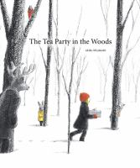
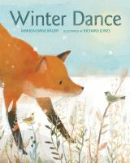
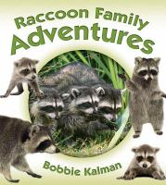
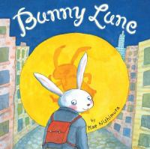

Bunny Lune by Kae Nishimura
Winter Dance by Marion Dane Bauer
Raccoon Family Adventures by Bobbie Kalman
Ancestor Approved: Intertribal Stories for Kids edited by Cynthia Leitich Smith
The Tea Party in the Woods by Akiko Miyakoshi

Recommended Online Resources
These links and videos have been reviewed before selection, but please consider reviewing them before allowing your child to view them.

https://www.amnh.org/exhibitions/permanent/north-american-mammals
https://www.amnh.org/exhibitions/permanent/north-american-forests
View museum exhibits featuring animals and forests from across North America from the American Museum of Natural History

https://www.youtube.com/watch?v=XhQZzDQiDsk
Some of the cute animals from North American forests and fields

https://www.youtube.com/watch?v=6YD14WM9j80
Video about conservation efforts for the prairie

https://www.dec.ny.gov/outdoor/55430.html
New York State Department of Conservation “Watchable Wildlife” list

Squirrel Towel Roll Craft
(from https://www.easypeasyandfun.com/squirrel-toilet-paper-roll-craft/)

Materials

Paper Roll
Scissors
Glue
Acrylic paint
Color paper
White paper
Black marker
Paintbrush

- Cut one third of the paper roll off and cover the remaining in paint.
- Cut a strip of color paper, two ears, two paws and a long heart shape for feet then cut off the point.
- On white paper, draw 2 big eyes and cut out. Add eye details.
- Lay the roll down so the two open ends are on the left and right. Glue on the eyes toward the edge of each side of the roll. Add nose and mouth details, including teeth, in the middle.
- Glue the hands inside the tube sticking out and the ears above the eyes. Tip: Put glue along the flat side of the ear in a thin line, then bend the rest of the ear up so it is 3-D.
- Place glue on the bottom half of the heart where you cut the point off and stick the feet to the bottom of the tube. Fold the rounded edges of the heart down so that your squirrel can stand up.
- Wrap the stripe of paper around your marker and let it go to make a curled tail. Glue the tale to the back of the tube so it is sticking up.
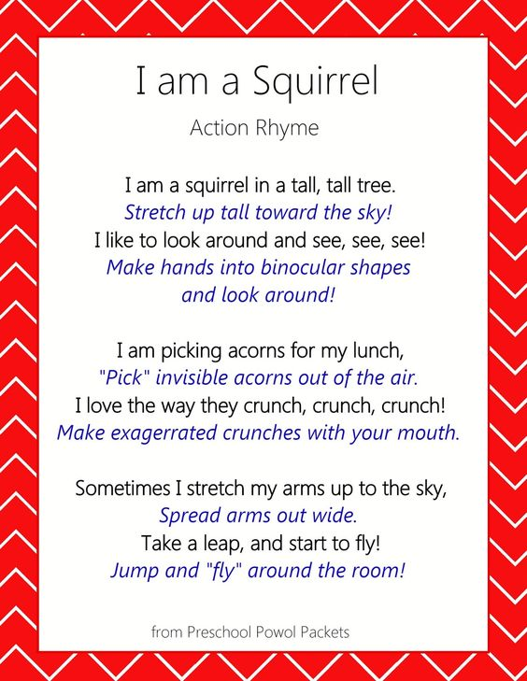
Dough Nature Portraits
Go on a nature walk and collect things that are laying on the ground: leaves, flower petals, small sticks, pinecones, and anything else you can find. Think about what kind of shapes you will need for your portrait: eyes, nose, mouth, eye brows, hair, etc.
http://preschoolpowolpackets.blogspot.com/2017/09/squirrel-action-rhyme-rhymes-for-kids.html

Set up some playdough (or make your own) and use the materials you collected to create faces! Take a picture, take everything out and try again.

For an animal connection: find a picture of your favorite animal and try to recreate it using the materials you found on your nature walk.

