Going on A Safari Extension Activity Sheet
Thank you for checking out our kit! The following suggestions are provided to assist you in your family’s exploration of animals based on our theme of Tales and Tails. We hope you use these resources to continue habits of learning, curiosity, and reading.

Recommended Additional Titles
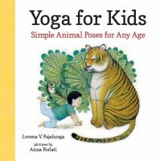
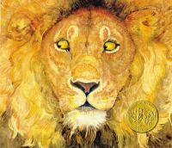
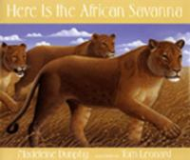
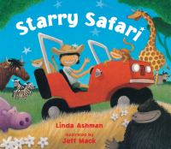
See also our curated list for related titles, available at: www.perry.owwl.org or by stopping into the library.

Starry Safari by Linda Ashman
Twenty-One Elephants and Still Standing by April Jones Prince
Here is the African Savanna by Madeleine Dunphy
Yoga for Kids: Simple Animal Poses for Any Age by Lorena V. Pajalunga
The Lion & the Mouse by Jerry Pinkney

Recommended Online Resources
These links and videos have been reviewed before selection, but please consider reviewing them before allowing your child to view them.

https://www.youtube.com/playlist?list=PLQlnTldJs0ZTKflWSiTrVXAd2nUufSYvr
National Geographic for Kids Safari Live Videos Playlist

https://wildearth.tv/live-safaris/
FREE! Live safaris with guides who will answer your questions as the tour happens

https://kidsdiscover.com/spotlight/african-safari-for-kids/
Spotlight on African safari from Kids Discover

https://animals.sandiegozoo.org/habitats/savanna
In-depth look at the plants and animals of the savanna

Paper Plate Sloth from https://www.ourkidthings.com/paper-plate-sloth-craft/
Materials

Paper Plate
Paper
Markers
Glue
Scissors

Optional: Stapler
Optional: Brown paint

- Cut paper plate in half. Either color with markers or paint and let dry.
- Cut out the inner part of the plate. Cut a circle from the inner part just cut off.
- Trace the circle onto a piece of paper and cut the paper circle slightly smaller.
- Take the outside part of the paper plate and place it so that the opening is toward you. Staple or glue the painted circle to the left outside edge of the paper plate arch about 2 inches from the end. Glue the paper circle on top of the plate circle, making sure it’s centered.
- Cut rectangles from paper (either brown or colored brown) and round off one end. Draw on the eyes and glue onto the face with the rounded edge into the middle and the straight edge close to the edge of the face.
- Draw on the rest of the face, and then the toes at either end of the arch.
- Cut a long strip of paper (either brown or colored brown) and cut out some leaves (around 4) from paper (either green or colored green). Glue or staple the strip to either end of the sloth’s toes, then add the leaves as you like. Add details to the branch and the leaves using markers.
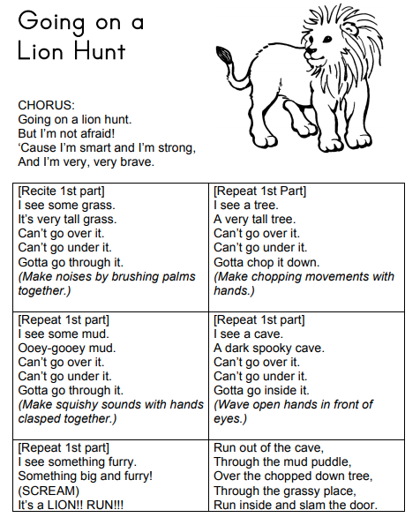
3-D Cardboard Zoo
http://supermakeit.com/blog/2018/4/10/
colorful-cardboard-zoo-animals

Materials
https://www.prekinders.com/safari-theme/

Animal Templates from website
Corrugated cardboard
Scissors
Assorted paints
Paint brushes
Pipe cleaners
White glue

- Cut out templates. Trace onto cardboard and cut out.
- Paint animals and let dry.
- Cut pipe cleaner for tails and tasks. Glue to cardboard
- Cut slits according to templates and assemble animals so they stand up.

