Extension Activity Sheet
Thank you for checking out our kit! The following suggestions are provided to assist you in your family’s exploration of animals based on our theme of Tales and Tails. We hope you use these resources to continue habits of learning, curiosity, and reading.

Recommended Additional Titles
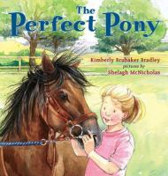
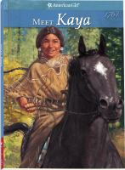
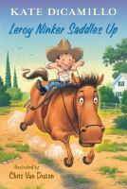
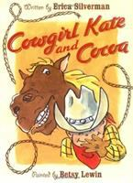
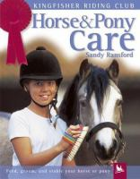
See also our curated list for related titles, available at: www.perry.owwl.org or by stopping into the library.

Horse & Pony Care by Sandy Ransford
Leroy Nickers Saddles Up by Kate DiCamillo
Cowgirl Kate and Cocoa by Erica Silverman
Meet Kaya by Janet Beeler Shaw
The Perfect Pony by Kimberly Brubaker Bradley

Recommended Online Resources
These links and videos have been reviewed before selection, but please consider reviewing them before allowing your child to view them.

https://www.amnh.org/explore/ology/zoology/all-about-horses
American Museum of Natural History: All About Horses

https://www.chincoteague.com/ponies.html
https://www.nps.gov/asis/learn/nature/horses.htm
https://www.youtube.com/watch?v=2ulkBctY_JM
Learn more about the Chincoteague Ponies made famous by author Marguerite Henry. Plus, watch the famous swim!

https://www.youtube.com/watch?v=gG8faNGg6os
Training a horse to ride

Unicorn/Horse Footprint

Paint
Paper
Markers
Paintbrush
Optional: Glitter

- Make sure the foot is clean and dry. The heel of the foot should be in one corner of the paper and the toes pointed toward the middle at an angle. The toes will be where the main comes from. Either paint the foot or trace around it. Suggested colors: black, brown or grey but be creative! Let paint dry.
- Add details, such as making the nose white, nostril, eyes, ears, bridle and reins, using paint or markers.
- Add the mane, try using a few different shades of your desired color.
- Add glitter if desired.
Unicorn Variation
- Trace or paint foot in white, again with the heel in a corner and the toes pointing toward the middle of the paper. Let dry
- Add a horn and mane, as well as eyes, nose, mouth, etc.
- Add glitter if desired.
Pool Noodle Horse
(From https://mycrazyblessedlife.com/2013/05/13/pool-noodle-horses/)
Pool Noodle
Duct tape
Googly Eyes
Fabric Scraps or yarn
Felt
Hot Glue Gun *Adult supervision!*

- Fold one end of the pool noodle over for the head, approximately 12 inches. Secure with duct tape. Use either duct tape folded over or string/yarn for the reins.
- Add your details: eyes, hair from fabric or yarn, felt ears, etc. using the hot glue gun.
- Ride off into the sunset on your gallant steed!
