Man’s Best Friend: Dog Extension Activity Sheet
Thank you for checking out our kit! The following suggestions are provided to assist you in your family’s exploration of animals based on our theme of Tales and Tails. We hope you use these resources to continue habits of learning, curiosity, and reading.

Recommended Additional Titles
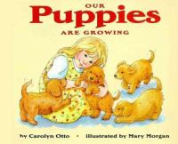
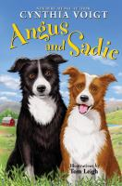
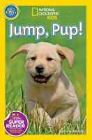
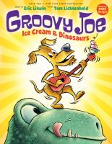
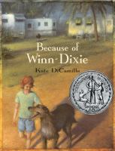
See also our curated list for related titles, available at: www.perry.owwl.org or by stopping into the library.

Angus and Sadie by Cynthia Voigt
Our Puppies are Growing by Caroline Otto
Jump, Pup! by Susan B. Neuman
Groovy Joe Ice Cream & Dinosaurs by Eric Litwin
Because of Winn-Dixie by Kate DeCamillo

Recommended Online Resources
These links and videos have been reviewed before selection, but please consider reviewing them before allowing your child to view them.

https://www.akc.org/dog-breeds/
List of recognized dog breeds by the American Kennel Club.

https://www.youtube.com/channel/UC-XByv4YD6jzp-c1bNCPJjw
Youtube channel of the American Kennel Club, includes read to dogs, meet the puppies, and more!

https://www.aspca.org/pet-care/dog-care
General tips on how to care for a dog

https://www.youtube.com/watch?v=kqnB76cQSd0
Dog Agility competition highlights

Dog Fridge Critter
(From https://activitiesforkids.com/clothespin-crafts-fridge-critters/)

Wooden Clothespins
Markers or Paint
Scissors
Craft foam or Cardboard
Googly eye
Glue
Pipe cleaners
Decorations
Yarn
Magnets

- Color clothespin desired color for dog.
- Cut out a heart shape and 2 tear drop shapes from craft foam or cardboard.
- Glue heart onto the closed end of the clothespin for face. Glue on tear drop shapes for ears. Add decorations like eyes, nose, freckles, etc.
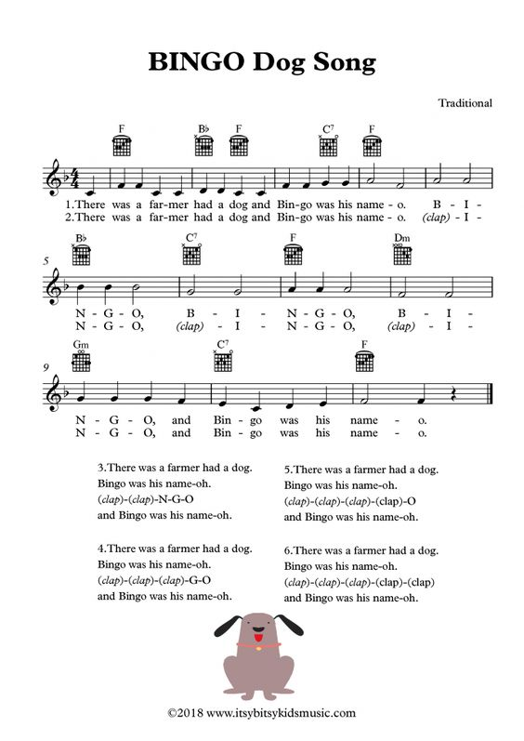
- Glue on pipe cleaner for tail. Glue magnet on back.
Dog Bookmark
https://www.redtedart.com/origami-bookmark/
https://www.redtedart.com/dog-corner-bookmark/

White paper
Pens
Glue
Contrast paper or markers
Scissors

- Make your white paper a square. You can do this by folding one corner to the opposite side and cutting off the strip that does not have two layers.
- Turn the open point of the triangle so it is away from you.
- Fold the right corner up to meet the open point. Then fold up the left corner to meet the open point. You should have a diamond shape.
- Unfold to the original triangle. Take the top sheet of the open corner and fold down to the bottom of the triangle.
- Take the right corner and tuck it into the folded down top sheet. Do the same for the left. The part that will show is the shorter of the two sides.
- Decorate your bookmark using the contrast paper or markers. Make sure to add a nose, eyes, and ears, maybe even a tongue.
https://itsybitsykidsmusic.com/index.php/portfolio/bingo-dog-song-sheet-music-with-chords-and-lyrics/

