Pets Extension Activity Sheet
Thank you for checking out our kit! The following suggestions are provided to assist you in your family’s exploration of animals based on our theme of Tales and Tails. We hope you use these resources to continue habits of learning, curiosity, and reading.

Recommended Additional Titles
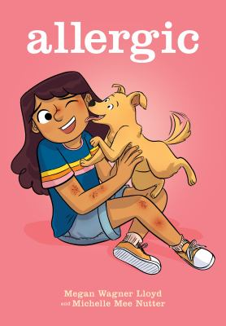
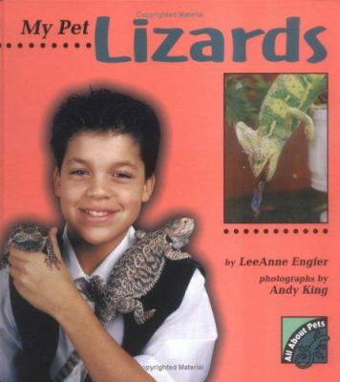
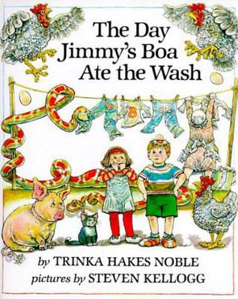
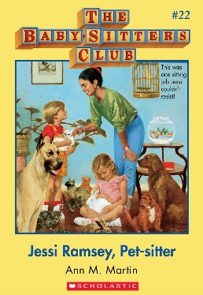
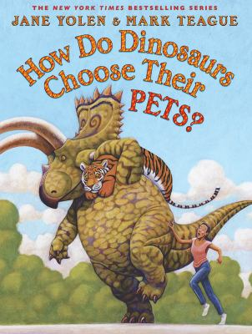
See also our curated list for related titles, available at: www.perry.owwl.org or by stopping into the library.

Allergic by Megan Wagner Lloyd & Michelle Mee Nutter
How Do Dinosaurs Choose Their Pets? by Jane Yolen & Mark Teague
The Day Jimmy’s Boa Ate the Wash by Trinka Hakes Noble
Jessi Ramsey, Pet-sitter by Ann M. Martin
My Pet Lizards by LeeAnne Engler

Recommended Online Resources
These links and videos have been reviewed before selection, but please consider reviewing them before allowing your child to view them.

https://www.avma.org/resources/pet-owners/petcare/selecting-pet-your-family
How to choose a pet, with links to articles on choosing specific animals

https://www.youtube.com/watch?v=wuZ48qGyRqI
Exotic Pets at the Vet from National Geographic for Kids

https://www.youtube.com/watch?v=IhixFwZiNEw
How to be the Best Pet Owner from National Geographic for Kids

https://www.pbs.org/video/why-do-people-have-pets-oglh24/
Exploration of how pets came to be kept for comfort with a focus on cats and dogs.

Pet Rocks
(from https://fun-a-day.com/fun-with-pet-rocks-a-camping-themed-craft/ and https://buggyandbuddy.com/pet-rocks/)
Materials:

Rocks (from outside or craft or home improvement store)
Paint or Paint Markers- Acrylic is best for brighter colors
Paintbrush
Googly Eyes
Glue

- Clean the rocks to ensure the paint sticks well. Dry off with paper towel or allow to dry in the sun.
- Paint the rocks with fun colors, designs, or be inspired by your favorite animal.
- Add googly eyes.
- Make a house for your pet rock out of recycled materials and give it a name!

Alphabet Puppy Chow
(From https://www.pre-kpages.com/alphabet-puppy-chow-game/)
Materials:

Stuffed Animal (dog) or Sock Puppet
Magnet
Glue
Bowl
Magnetic Letters (Upper and lowercase)
Optional: Recording sheet
Optional: Bingo Dauber

- Glue a magnet to the end of the stuffed puppy’s nose. You can also make a sock puppet if you do not have a toy.
- Place the magnetic letters in the bowl and give the puppy to your child.
- Using the puppy, the child will pick up the letter then identify it, either verbally or by recording on the sheet shown on the website (paper with dog bone outline, with letters inside). Repeat until all the letters in the bowl are used.
- This activity can also be used for colors, sight words, shapes, numbers, etc. Instead of using the magnetic letters, use paper and place a paper clip or magnet on each. The recording sheet can also be adapted to allow identification of the new concept.
- You could also use the letters to make words, similar to Scrabble. Draw out a set number of letters and see how many words you can make.

Pet Needs Song
Tune of “When the Saints Go Marching In” -From KindyKats on Teachers Pay Teachers

Oh every pet,
Has certain needs,
To be the best pet it can be.
Oh a pet needs food and water,
So it lives life happily!

Alternative verses: Replace 4th line with:
Oh, a pet needs to stay healthy
Oh a pet needs a bed for sleeping
Oh a pet needs excercising
Oh a pet might need some grooming
Oh a pet needs lots of love.

