Extension Activity Sheet
Thank you for checking out our kit! The following suggestions are provided to assist you in your family’s exploration of animals based on our theme of Tales and Tails. We hope you use these resources to continue habits of learning, curiosity, and reading.

Recommended Additional Titles
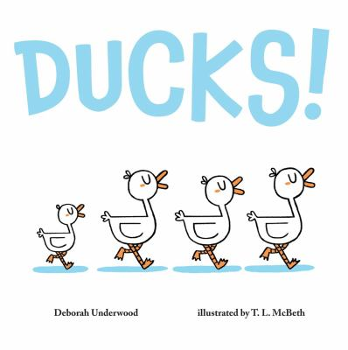
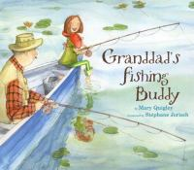
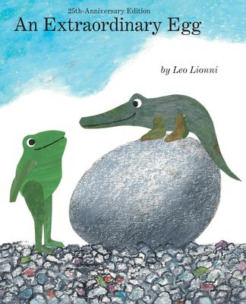
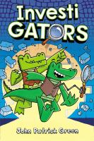
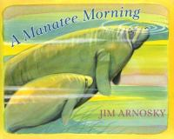
See also our curated list for related titles, available at: www.perry.owwl.org or by stopping into the library.

Granddad’s Fishing Buddy by Mary Quigley
An Extraordinary Egg by Leo Lionni
InvestiGATORS by John Patrick Green
A Manatee Morning by Jim Arnosky
Ducks! by Deborah Underwood

Recommended Online Resources
These links and videos have been reviewed before selection, but please consider reviewing them before allowing your child to view them.

https://www.youtube.com/watch?v=Egu9lw_CaRA
Family Fishing Basics from the NY Dept of Environmental Conservation

https://wri.cals.cornell.edu/hudson-river-estuary/education/virtual-river-students-teachers-and-families/
The Virtual River website (the Hudson River)

https://www.youtube.com/watch?v=gBRcOLcEwF0
What’s so Great About the Great Lakes? TedEd Video

https://www.youtube.com/playlist?list=PLrfcruGtplwGrcWF-adPH-1BsR9JH-FRw
Pond Life Playlist- American Museum of Natural History

http://www.letchworthparkhistory.com/flood.html
https://nyheritage.org/collections/flood-1972-genesee-river-letchworth-state-park
Historic photos and recollections of Genesee River & the flood of 1972

https://www.youtube.com/watch?v=e8maiRMKFLY
Virtual Tour-Mt Morris Dam

3-D Crocodile in River (inspired by Pinterest post)
Paper-blue, green, red/pink, white, tan
Markers
Glue or tape
Scissors

- If you do not have the color paper, you can also color white paper with crayons or markers and then use that instead.
- Cut out a river from the blue paper and glue it to the tan paper.
- Draw a rectangle for the crocodile’s body and cut it out. Then trim one end to a point for the tail. Add scaly details if desired. Then fold accordion style (like a fan) starting with the head and ending with the tail. Allow to spring open.
- Cut a smaller rectangle and fold in the short way to make the head and mouth. Again, add details as desired, including the nostrils. Glue to the body.
- For inside the mouth, cut the red or pink paper to fit. Add teeth details. If you want them to stand up, make the tooth a little longer, fold a thin line and place glue to attach to the mouth area.
- Cut out two eyes, adding a little extra at the base to fold put glue and decorate with markers. Fold and glue to the head near where it connects to the body.
- Cut out 4 ovals for arms and legs and glue down to the river. Then glue down the body and the head.
- Add details to the river to make it seem like it’s flowing and gravel details to the sand.

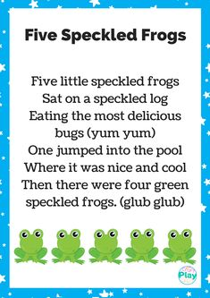
Pool Noodle Fishing
(From https://happytotshelf.com/pool-noodle-fishing-game/ )
https://www.craftplaylearn.com/five-speckled-frogs-printable-and-activity-ideas/
Pool noodle
Paper clips
Pipe cleaners
Googly eyes (optional)
Magnet
Sticks as fishing rods
String
Penknife
Hot glue

- Cut the pool noodle into 2 inch pieces.
- Bend and twist the pipe cleaner into a triangle.
- Cut small slits at front and back. In one slit, add a paper clip and in the other, add the pipe cleaner for the tail.
- Glue on googly eyes (optional).
- Make the fish rod with a stick, string and magnetic clasp.

