Extension Activity Sheet
Thank you for checking out our kit! The following suggestions are provided to assist you in your family’s exploration of animals based on our theme of Tales and Tails. We hope you use these resources to continue habits of learning, curiosity, and reading.

Recommended Additional Titles
See also our curated list for related titles, available at: www.perry.owwl.org or by stopping into the library.
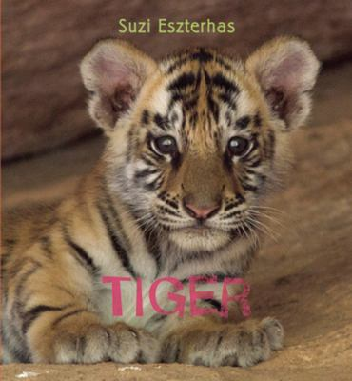
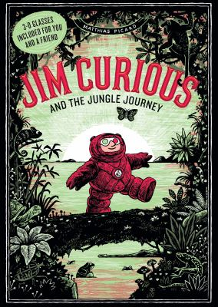
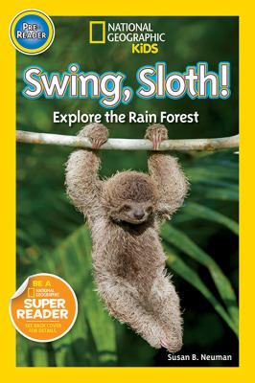
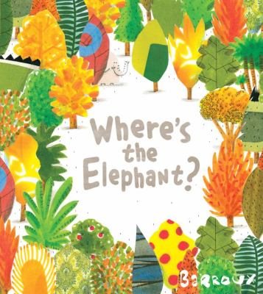
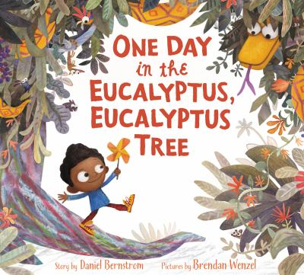

One Day in the Eucalyptus, Eucalyptus Tree by Daniel Bernstrom
Swing, Sloth! Explore the Rain Forest by Susan B. Neuman
Where’s the Elephant? by Barroux
Jim Curious and the Jungle Journey by Matthias Picard
Tiger by Suzi Eszterhas

Recommended Online Resources
These links and videos have been reviewed before selection, but please consider reviewing them before allowing your child to view them.

https://www.youtube.com/watch?v=unSMbDbC1-M
Virtual Field Trip through the Amazon Rainforest

https://www.youtube.com/watch?v=D_86EfXIiWc
Jungle Animal Names and sounds

http://www.srl.caltech.edu/personnel/krubal/rainforest/Edit560s6/www/animals.html
Interactive tour of animals in the rainforest. Includes lessons and supplemental materials

https://nationalzoo.si.edu/sites/default/files/documents/great_kapok_tree_-_layers_and_movement.pdf
Presentation by the Smithsonian National Zoological Park Conservation Biology Institute about the layers of the rainforest and animals that live there.

Handprint Monkey
(from https://www.simpleeverydaymom.com/handprint-monkey-craft/)

Paper- pink, green, brown, tan/cream
Scissors
Pencil
Pink marker
Glue stick
Optional-monkey template from website

- Trace your child’s hand onto brown paper. Cut out.
- If you are not using the template, draw a circle and cut out of brown paper. Draw and cut out two small circles for ears and glue to head. Optional: cut out smaller pink circles for the inner ear.
- For the face, use the lighter brown/cream color. Draw and cut out the shape of a piece of bread that is slightly smaller than the circle for the head. Add the eyes, nose and mouth before gluing to the face.
- Glue the head to the thumb of your hand tracing.
- Draw and cut out a tail from your brown paper. Glue onto the back of the palm.
- Cut a curving stripe of green for the vine.
- Glue the pointer finger to the back of the vine, the middle finger to the front, the ring finger to the back and the pinky finger to the front.

Jungle Relay Race
(From https://birthdaypartyideas4kids.com/jungle-party.htm)
Set up several relay races using Jungle themes. Separate the players into two teams. On the relay course you will need an object that the kids will need to run around or touch on the other side of the playing field before they can return to their team and the next person in line takes their turn. A large potted plant or stuffed animal on a chair is a great idea for a turnaround point in the relay race.

Fun jungle themed relays:
Snake Crawl - Crawl on your belly - arms, legs, hands and feet can’t be used.
Monkey Run - Run with your hands touching the floor.
Tiger Balance - Balance a stuffed tiger on your head.
Elephant Walk - Walk like an elephant - clasp your hands together and then hold them down in front of your body like an elephant trunk. Swing your trunk back and forth as you run through the course.
Jungle Song
Tune of Twinkle, Twinkle Little Star
(excerpt from https://www.earlylearninghq.org.uk/themes/jungle/jungle-song/)

Tiger, tiger, orange and black
He’s got stripes upon his back.
When he growls sharp teeth I see,
He’s as scary as can be!
Tiger, tiger, orange and black
He’s got stripes upon his back.
Elephant, elephant, large and grey,
Swings his trunk along the way.
His ear are big, his tusks are white
Don’t be scared he does not bite!
Elephant, elephant, large and grey,
Swings his trunk along the way.

