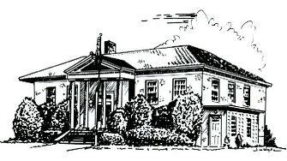

PERRY PUBLIC LIBRARY

70 N. Main Street Make It Part of Your Day
Perry, New York 14530

PHONE (585) 237-2243 FAX (585) 237-2008 WEBSITE perry.owwl.org

Library Board Meeting Agenda
December 6, 2021
1.) | Pledge to Flag
2.) | Consideration of Agenda and Conflict of Interest | DISCUSS
3.) | Public Comment
4.) | Approval of November 1st Minutes | VOTE
5.) | Account Payable Voucher | VOTE
6.) | YTD Budget 2021 | REVIEW AND DISCUSS
7.) | Budget 2022  1.) Director Salary Adjustment | REVIEW  VOTE
8.) | Staff Reports  1.) Director’s | DISCUSS
9.) | Committee Reports  1.) Budget & Building Committee | DISCUSS
10.) | New Business | DISCUSS
11.) | Old Business  1.) Masking Policy | DISCUSS
 | Adjourn | VOTE
Dates | December 14th- Development Committee Meeting 4:00 pm  December 27th- Year End Board Meeting 4:00 pm

