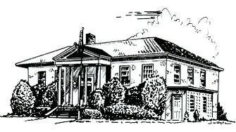

PERRY PUBLIC LIBRARY

70 N. Main Street Make It Part of Your Day
Perry, New York 14530

PHONE (585) 237-2243 FAX (585) 237-2008 WEBSITE perry.owwl.org

Library Board Meeting Agenda
December 27, 2021
1.) | Pledge to Flag
2.) | Consideration of Agenda and Conflict of Interest | DISCUSS
3.) | Public Comment
4.) | Account Payable Voucher | VOTE
5.) | YTD Budget 2021 | REVIEW AND DISCUSS
6.) | Committee Reports  1.) Development Committee  Staff Pay Raises | DISCUSS  VOTE
7.) | Old Business  Construction Updates  1.) Electric  2.) Foundation Repairs  Heilbronner Donation | DISCUSS
8.) | Adjourn | VOTE
Dates | January 3rd, 2022 @ 7pm- January Board Meeting

