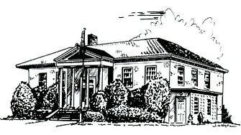

PERRY PUBLIC LIBRARY

70 N. Main Street Make It Part of Your Day
Perry, New York 14530

PHONE (585) 237-2243 FAX (585) 237-2008 WEBSITE perry.pls-net.org

Jessica N. DeMarte, Director E-MAIL: jdemarte@pls-net.org

Closing Policy

If the library cannot be staffed, the library will be closed. This determination will be made by the library director after all attempts have been made to adequately staff the library. The library director will determine what is adequate staffing for each situation.

In severe weather or other conditions, if the library director feels there is a public safety concern, they may make the decision to close the library.

Every effort shall be made to inform the community through social media and local media outlets of any such closing as soon as possible. The library board will be informed of the closing in a reasonable amount of time.

If a staff member cannot get to work or remain in the library due to concerns for their safety, they are excused without prejudice.

Closing for other reasons, such as construction work, repairs or loss of power will be made by the library director, in conjunction with the library board if time allows.

