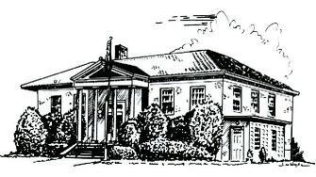

PERRY PUBLIC LIBRARY
70 N. Main Street Make It Part of Your Day
Perry, New York 14530
PHONE (585) 237-2243 FAX (585) 237-2008 WEBSITE perry.owwl.org
Jessica N. DeMarte, Director E-MAIL: jdemarte@pls-net.org

Budget & Building Committee Minutes
May 18, 2022

In attendance: Bethany Zerbe, Priscilla Popp, Jessica DeMarte (Director), Dave Shearing, Lorie Ames (7:10pm).

Bethany Zerbe called the meeting to order at 7:0 pm.

The committee reviewed three quotes received for door replacement. The committee discussed the door quotes and discussed the alarm quotes received previously.

Bethany Zerbe made a motion to approve the Intent to Apply for Construction Aid 2023 for the Door & Alarm Replacement projects, at approximate total cost of $22,569.66. Dave Shearing was the second and the motion passed the full committee. Director DeMarte will submit by the June 1st deadline.

The committee discussed the brick walkway. Director DeMarte provided updates on the stones, installation labor, & is working on getting a quote from the engravers.

Director DeMarte provided an update on garbage. Waste Management will honor our current pricing.

A brief discussion was held on Paid Family Leave and Paid Time Off as discussed in Development Committee.

A brief discussion was held regarding a raise in pay for Sarah Emerson, due to increase job duties. The committee discussed a range that would fit the current budget and sent the discussion back to the Development Committee for rate approval.

Bethany made a motion to accept the contract from Bonn, Dioguardi, & Ray for the 2021 Financial Review at a cost of $2200. Priscilla was the second and the motion passed the full committee.

The meeting was adjourned at 8:06 pm.

Respectfully submitted,
Jessica DeMarte.

